IKEA Six Round Up’s

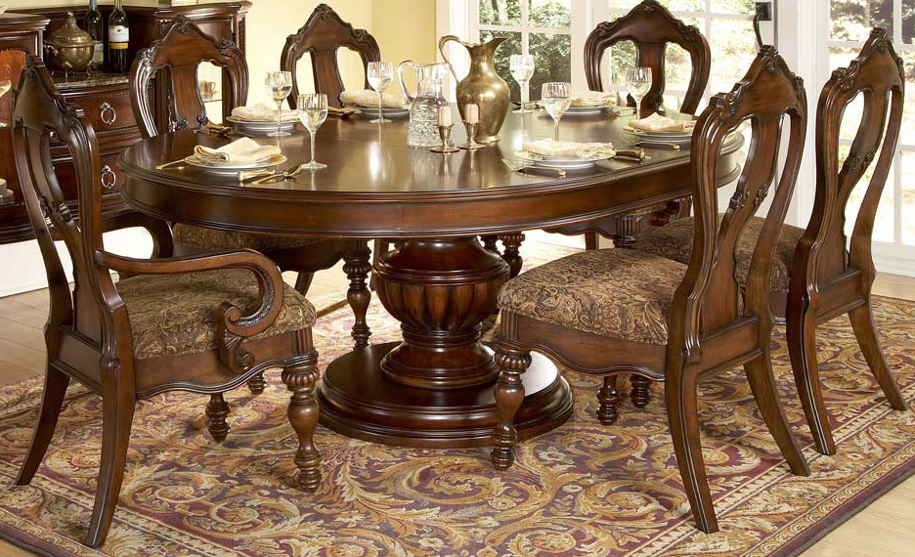

|  |
| --- |
| **DESCRIPTION** |
| IKEA interior design presents a stylish wooden dining set with a rich glow finish on top the set of oval table and chairs are perfect to create the durable surrounding. The rich onyx wood on top enables potential to decorate objects with different styles and light touch feeling top and let’s not forget about chairs because they are built to summon relaxation. |

|  |  |  |
| --- | --- | --- |
| **Price** | **3000$** | |
| **Dimensions** | **Table H** x **R** x **L** | **54in x 21in x 64in** |
| **Chairs H** x **W** x **L** | **42in x 29in x 33in** |
| **Features** | **Six Chairs and One Table supported by round thick natural tree plate and natural onyx wood will give a cool and relaxing smell.** | |
| **Finished** | **Linters Shine** | |
| **Available in** | **Dark Brown Only** | |